# Project

## Background

A **region** defines a geographical area, e.g. Auckland. A **branch** is a retail shop, located in a region.

## Requirement

Customers can become members of the retail shop. The customer will be associated with the branch they commonly shop at.

## Task

The database needs two new tables: **Region** and **Branch**. Design those tables on the whiteboard, indicating the column names and data types. Also demonstrate knowledge of SQL objects and schema, by describing how to achieve the table rules.

**STEP 1. Find all entity in the project.**

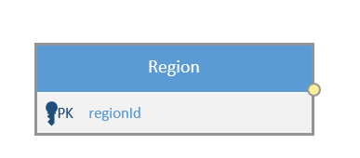

Region

Branch

**STEP 2. Find the relationship of entity**

Branch and Region

* Does region have many branches? YES
* Does a branch only belong to one region? YES
* Does branch belong into multiple region? NO

**One to many relationships between region and branch**

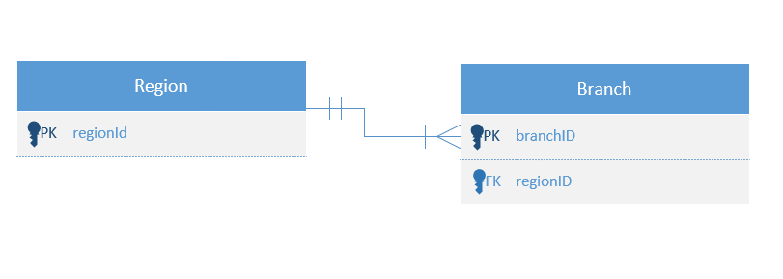

**STEP 3: Find all the attribute needed per project. Do not add anything.**

Entity1: Region

Attrib1 : regionID integer, primary key ,not null ,auto generated

Atttrib2: regionName string, unique, not null

Entitiy2: Branch

Attrib1: branchID integer, primary key ,not null ,auto generated

Attrib2: branchName string, unique, not null

Attrib3: regionID foreign key int not null

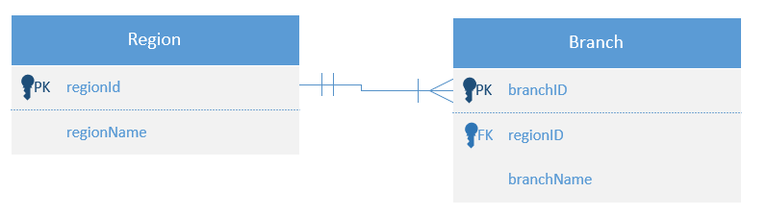

**Step 4: Build database**

### Region

Data to be stored

* An internal region number, only used by the software. The user never sees this.
* The name of the region. Can’t be blank.

Table rules

* The internal number must be different on every record.
* The name must be different on every record.

CREATE TABLE [dbo].[Region]

(

[regionID] [int] IDENTITY(1,1) NOT NULL primary key,

[regionName] [varchar](50) NOT NULL,

CONSTRAINT regionName_unique UNIQUE (regionName)

)

### Branch

Data to be stored

* An internal branch number, only used by the software. The user never sees this.
* The name of the branch. Can’t be blank.
* The region this branch is located in.

Table rules

* The internal number must be different on every record.
* The name must be different on every record.
* The region must exist in the Region table.

CREATE TABLE [dbo].[Branch]

(

[branchID] [int] IDENTITY(1,1) NOT NULL primary key,

[branchName] [varchar](50) NOT NULL,

[regionId] [int] NOT NULL foreign key references Region(regionID),

CONSTRAINT branchName_unique UNIQUE (branchName)

)

## Find all branches in the Auckland region

The application displays a list of branches in each region. Write a statement to return all branches in the Auckland region.

SELECT

br.branchName

FROM

[dbo].[Region] reg

JOIN

[dbo].[Branch] br

ON

br.regionID = reg.regionID

WHERE

reg.regionName = 'Auckland'

TYPE OF CONSTRAINT IN SQL

SQL NOT NULL – attribute data is not empty

UNIQUE – no data are the same, accept null value

PRIMARY KEY – no data are the same. No null.

FOREIGN KEY – one to many relationship.

CHECK – This will the data before it will store in the database

DEFAULT – This will store a default value in the table. Example is getdate command